Modeling Human Activity States Using Hidden Markov Models
Data samples + figures: https://drive.google.com/drive/folders/1BTKM0rzmr4JsPGPFq0EtbHEy2CI8LW1Z?usp=sharing
Videos for each activity: https://drive.google.com/drive/folders/1UWbGBchA8pgfBlWkgFdKmsCR_VeKUwoi?usp=sharing

Section 1: Background and motivation
Smartphones contain accelerometers and gyroscopes capable of tracking human movement to monitor health, detect falls, and power context-aware applications without requiring costly dedicated wearables. However, raw sensor data is noisy, and real-world human activities follow sequential patterns rather than random second-by-second changes. To address this, I built a Hidden Markov Model (HMM) from scratch by combining sensor-derived emission probabilities with activity transition probabilities. Using accelerometer and gyroscope data I recorded across four activities (standing, walking, jumping, and still), I trained the model with the Baum-Welch algorithm, decoded activity sequences on unseen recordings using Viterbi, and evaluated its predictive accuracy. My use case is a phone-based home-exercise tracker: it should count active time (walking, jumping), tell it apart from resting while holding the phone (standing), and notice when the phone has been put down (still), so that time off the body is not logged as rest.

Section 2: Data collection and pre-processing
Data collection. I recorded motion data with the Sensor Logger app on my smartphone which is an android, using only the accelerometer and gyroscope (x, y, z each). I recorded four activities: standing, walking, jumping and still (phone flat on a surface). For each activity I recorded 17 separate clips of about 5 to 10 s, giving 68 labelled files. Each file was exported as a CSV with a timestamp column, and the label was taken from the file name (for example Walking_07). I recorded extra clips after my first batch, because the first 13 clips per activity totaled less than the required 90 s for jumping and standing. After trimming, each activity has between 93 s (jumping) and 105 s (still) of data. Video evidence of me recording each activity is linked here: Standing [video_standing.mp4], Walking [video_walking.mp4], Jumping [video_jumping.mp4], Still [video_still.mp4]. Physically I’m not going to lie,the jumping activity taxed me and took a whole out of me since the activities contain 17 files each.

Sampling rate. I set the app to 100 Hz, but when I checked the timestamps it was around 52.7 Hz on the phone for both sensors, and it did not drop out in any activity(largest interval between the samples was close to 0.02 s). There were also differences in the number of rows of the accelerometer and the gyroscope. I normalized both sensors on their time range, then re-sampled each of them to a common time grid of 50 Hz using linear interpolation. Only one phone was used, no need to harmonize between phones.
Cleaning. I cut out 0.5 s from the beginning and end of each clip, to get rid of the motion when pressing start and stop buttons. Some of the clips are a bit longer (raw clips ranged from 4.9 s to 10.5 s, and three clips were used for jumping which are about 3.9 s after the clips were trimmed), but they still produce at least one full window.

Windowing. The windows of 2 s (100 samples at 50 Hz) and 50% overlap (1 s step) were used for each signal. I chose this window size because 2 s (100 samples) holds about three jumping cycles (~0.7 s each) and two to three walking steps, giving an FFT resolution of 0.5 Hz. Jumping (~1.5 Hz) and walking (~1.4 Hz) have similar rhythms, but the acceleration magnitude peaks twice per jump (landing and free fall), so its dominant frequency is ~3.3 Hz for jumping against ~1.4 Hz for walking, several bins apart .
Unseen data. For testing, I recorded two further files, each containing all four activities back to back (about 10 s each) in a different order (walking, jumping, still, standing; and still, walking, standing, jumping). These were captured in another setting and in a different session after the training clips with the phone held in one hand in a lower position to the one used during training and with no breaks between activities. They were subjected to the same pre-processing steps and were not employed for training or feature design.

Figure 1 represents one sample of each activity (accelerometer and gyroscope) and jumping has large regular peaks, walking has a medium irregular oscillation, standing has a small wobble and still has almost flat accelerometer activity, the gyroscope activity is about 100 times smaller.
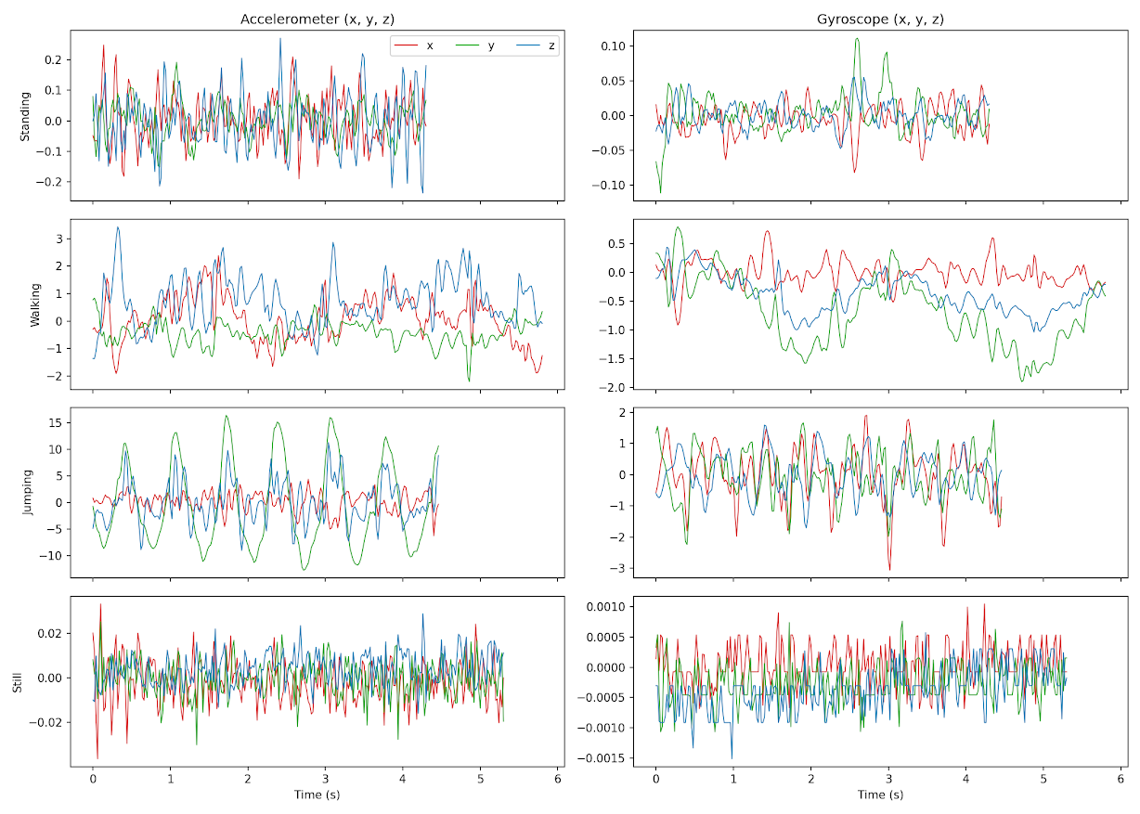

Section 3: HMM setup and implementation

Element | Definition in this project
Hidden states (Z) | Four activities: standing, walking, jumping, still
Observations (X) | An 8-dimensional feature vector per 2 s window (below)
Transition matrix (A) | 4×4 probabilities of moving from one activity to another between consecutive windows
Emission probabilities (B) | One Gaussian per activity over the 8 features (diagonal covariance): a mean and a variance for each feature
Initial probabilities (π) | Probability that a session starts in each activity
Features. From each window I computed 4 time-domain and 4 frequency-domain features. The frequency-domain features come from the FFT of the Hann-windowed signal magnitude, ignoring the DC bin.
Features were first normalized by applying a log10 transform to the std, SMA and energy features to deal with the fact that these features contain very large values, and then a Z-score transform, using all the means and standard deviations computed from the training windows only, and applied to the unseen data; this was performed to fit the Gaussian emission model. I have used Viterbi for inference and Baum-Welch (EM) for parameter estimation and reconstructed the HMM from scratch in NumPy, using log space computations. To avoid too many single activity clips switching to themselves, I created 17 training sequences, with the single activity clips linked sequentially, but not necessarily in order, (that is, 17 sequences of 296 windows). Then I used the labeled windows to initialise Baum-Welch, with a 0.01 variance floor (so no variance collapses to zero) and a tiny constant (10⁻⁶) added to the counts for A and π (so no probability becomes exactly zero) 533.07 to 534.23, and converged after 3 iterations. This produced strong self-transitions (0.77-0.86), but the learned off-diagonal transitions are not necessarily indicative of the actual behavior. Figure 2 shows the transition heatmap and the log-likelihood curve, and Figure 3 the emission means.
Figure 2: transition heatmap and the log-likelihood curve
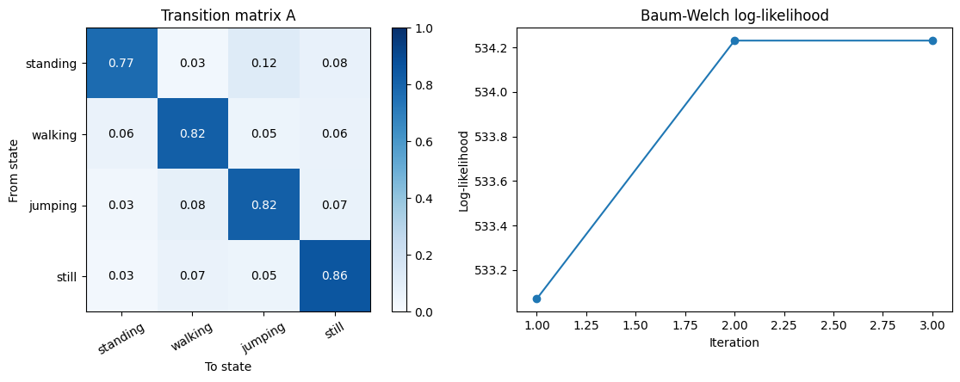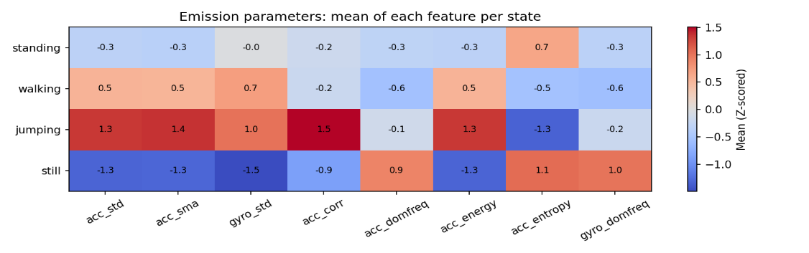
Figure 3:the emission means

Section 4: Results and Interpretation

The model was tested on two unseen recordings (73 windows total) with ground truth labels that were refined using the signals from the accelerometer. Overall, I managed to get an accuracy of 0.808 across all the windows (accuracy of 0.757 on Test_file_01 and 0.861 on Test_file_02). Excluding the 12 windows that crossed activity transitions, my accuracy increased to 0.902, and 8 out of the 14 total accuracy errors were in these 'activity switch windows'.
The confusion matrix displayed Perfect recognition for jumping (18/18) and hhigh accuracy for walking (18/20), while the lowest-motion states (standing and still) were the most difficult, since the gyroscope variance is the main feature separating them., and I noticed that the lowest motion (standing and still) were the most difficult to distinguish, especially with only the variance of the gyroscope. While I got a very high specificity for the still class, the classification errors were grouped around activity switches because there were overlaps of windows, as well as residual motion (i.e., settling into position). These results give a realistic, untuned view of the model's generalization, but they are limited by the number of windows that were recorded in each class (between 17 and 20), and in the variety of recording conditions. Figure 4 shows the confusion matrix while Figure 5 here compares the true and predicted sequences over time.
Figure 4: Confusion matrix
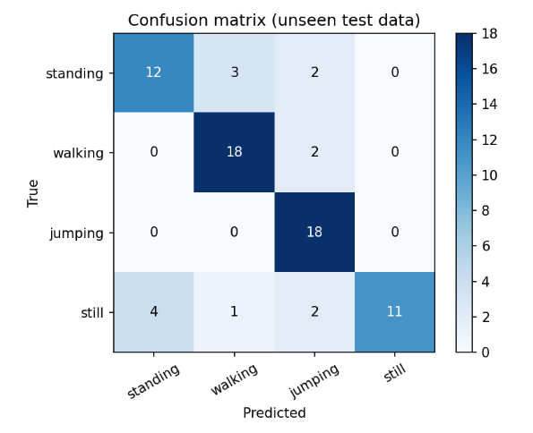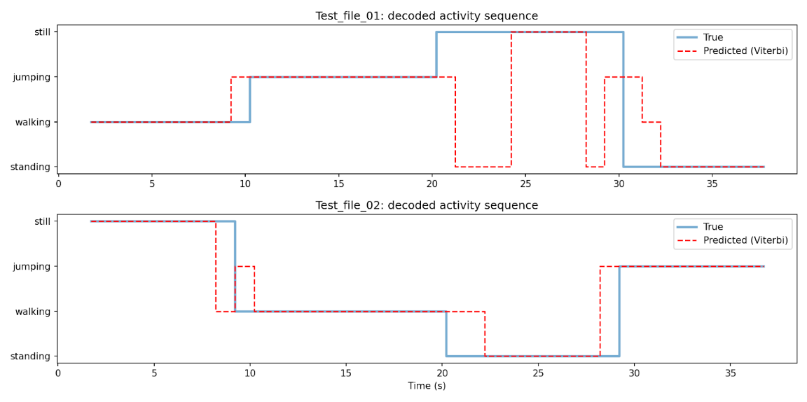
Figure 5: decoded sequences

Section 5: Discussion and conclusion
The self-transition probabilities (ranging between 0.77 and 0.86) were helpful for temporal smoothing, i.e., the resulting model was able to decode the middles of the activity segments well without switching back and forth between different activity types from second to second but this temporal inertia also resulted in somewhat delayed transitions at the activity boundaries. The off diagonal values, on the other hand (0.03 to 0.12), and the initial probabilities were not real human behavioral patterns, but rather artificial, random chaining of individual clips that I performed.

Looking at hardware and data collection, I found that the phone was programmed for 100 Hz, but that an average sampling rate was ~52.7 Hz. I found this error using timestamps and resampled the data to 50 Hz, whose Nyquist limit of 25 Hz is far above the walking (~1.4 Hz) and jumping (~3.3 Hz) rhythms. For still, the FFT peak lands on a random noise frequency (~8.1 Hz) caused by sensor noise rather than a behavioral rhythm. As a disclaimer, I didn't perform a sensitivity analysis on the impact of varying window and sampling rates on the performance of the model.

Looking at the overall limitations of the experiment, I realize that it was only a single participant, a single phone, two recording sessions on one day , and only 73 windows for testing, with 17-20 windows per sensitivity class. Moreover, the model was supervised based on labels and not discovery, and many of the classification errors were the result of continuous activity transitions without pauses in between.

In the future I would like to make several improvements to this work:

- Data Diversity: Capturing multiple sessions from hand-held, different bag, different pocket position and add held out test subjects.
- Natural Sequences: Record long sequences of natural switching events in a way that the transition matrices and initial probabilities are correct for human life.
- Improved Feature Engineering: Add stationary state features including body sway low-frequency power, gyroscope spectral energy, entropy and jerk.
- Shorter windows or smaller steps for better isolation of activity switches: Temporal Resolution
- Model Complexity: try full-covariance or mixture-of-Gaussian’s emission models.

In conclusion, training this Hidden Markov Model using the Baum-Welch algorithm, and decoding the unseen recordings using the Viterbi algorithm showed that a simple transition model combined with the basic time and frequency domain features can be used successfully to recognize smartphone-based activities. The findings indicate that the volume and variety of data is much more limiting than algorithmic restrictions are.

